**A PROJECT REPORT ON**

**MEDGUARD AI**

SUBMITTED TO

MIT SCHOOL OF COMPUTING, LONI, PUNE IN PARTIAL FULFILLMENT OF THE REQUIREMENTS FOR THE AWARD OF THE DEGREE

**BACHELOR OF TECHNOLOGY**

**(Computer Science & Engineering/ Information Technology)**

**BY**

Candidate Name Enrollment No:

Sudip Konde MITU22BTCS0859

Tanmay Khedekar MITU22BTCS0609

Sai Jagdale MITU22BTCS0692

Sujal Bafna MITU22BTCS0864

**Under the guidance of**

Prof. Dr. Rajendra Pawar



**DEPARTMENT OF COMPUTER SCIENCE AND ENGINEERING**

**MIT School OF COMPUTING**

MIT Art, Design and Technology University

Rajbaug Campus, Loni-Kalbhor, Pune 412201

**2025**



**MIT SCHOOL OF COMPUTING**

**DEPARTMENT OF COMPUTER SCIENCE AND ENGINEERING**

MIT ART, DESIGN AND TECHNOLOGY UNIVERSITY,

RAJBAUG CAMPUS, LONI-KALBHOR, PUNE 412201

**CERTIFICATE**

This is to certify that the project report entitled

**“MEDGUARD AI”**

Submitted by

Name of the Candidate Enrollment No: -----

Sudip Konde MITU22BTCS0859

Tanmay Khedekar MITU22BTCS0609

Sai Jagdale MITU22BTCS0692

Sujal Bafna MITU22BTCS0864

is a Bonafide work carried out by them under the supervision of Prof.Dr.Rajendra Pawar and it is submitted towards the partial fulfillment of the requirement of MIT ADT university, Pune for the award of the degree of Bachelor of Technology (Computer Science and Engineering)

**Prof.Dr.Rajendra Pawar Dr. Nandakumar Kulkarni**

Guide Head of Department

**Prof. Suresh Kapare Dr. Ganesh Pathak**

Chief Coordinator-PBL Dean

Seal/Stamp of the College

Place: PUNE

Date: 21/11/2025

**On Company Letter head/seal**

**CERTIFICATE**

This is to certify that the Project report entitled

**“MEDGUARD AI”**

Submitted by

Name of the Candidate Enrollment No: -----

Sudip Konde MITU22BTCS0859

Tanmay Khedekar MITU22BTCS0609

Sai Jagdale MITU22BTCS0692

Sujal Bafna MITU22BTCS0864

is a Bonafide work carried out by candidates under the supervision of Prof.Dr.Rajendra Pawar and has been completed successfully.

Prof. Dr. Rajendra Pawar

Guide

Seal/Stamp of the Company/College

Place : Pune

Date : 12/11/2025

**DECLARATION**

We, the team members

|  |  |
| --- | --- |
| Name | Enrollment No |
| Sudip Konde | MITU22BTCS0859 |
| Tanmay Khedekar | MITU22BTCS0609 |
| Sai Jagdale | MITU22NTCS0692 |
| Sujal Bafna | MITU22BTCS0864 |

Hereby declare that the project work incorporated in the present project entitled **“MEDGUARD AI”** is original work. This work has not been submitted to any University for the award or a Degree or a Diploma. We have properly acknowledged the material collected from secondary sources wherever required. We solely own the responsibility for the originality of the entire content.

Date: 12/11/2025

Name & Signature of the Team Members

Member 1: Sudip Konde

Member 2: Tanmay Khedekar

Member 3: Sai Jagdale

Member 4: Sujal Bafna

**Name and Signature of Guide**

Seal/Stamp of the College

Place: Pune

Date: 12/11/2025



DEPARTMENT OF COMPUTER SCIENCE & ENGINEERING

MIT SCHOOL OF COMPUTING,

RAJBAUG, LONI KALBHOR,

PUNE – 412201

**EXAMINER’S APPROVAL CERTIFICATE**

The project report entitled “MEDGUARD AI” submitted by Sudip Konde (MITU22BTCS0859), Tanmay Khedekar (MITU22BTCS0609), Sai Jagdale (MITU22BTCS0692), Sujal Bafna (MITU22BTCS0864) in partial fulfillment for the award of the degree of Bachelor of Technology (Computer Science & Engineering) during the academic year 2025-26, of MIT-ADT University, MIT School OF COMPUTING, Pune, is hereby approved.

**Examiners:**

**1.**

**2.**

**ACKNOWLEDGEMENT**

We would like to express our sincere gratitude to our project guide, Prof.Dr.Rajendra Pawar, for their invaluable guidance, support, and encouragement throughout this project. We also thank the faculty and staff of the CSE Department for providing resources and assistance. Special thanks go to Prof. Dr. Rajendra Pawar for insights and feedback. We are deeply grateful to our parents and friends for their constant support and encouragement during this endeavor. Finally, we acknowledge all researchers whose works and publications we consulted, which greatly aided in the development of this project.

Name of the Candidate Enrollment No: -----

Sudip Konde MITU22BTCS0859

Tanmay Khedekar MITU22BTCS0609

Sai Jagdale MITU22BTCS0692

Sujal Bafna MITU22BTCS0864

**ABSTRACT**

The spread of counterfeit and substandard drugs around India is a severe challenge to public health, as existing verification tools are often time-consuming, manual, and unreliable. This project presents MedGuardAI, a comprehensive Django-based web application designed to provide a fast, intelligent, and reliable solution for real-time drug authentication. It enables users to either enter a medicine name, upload a picture of the package, or scan a barcode to instantly verify the drug’s authenticity and details.

At the core of MedGuardAI lies an agentic AI workflow, where several specialized agents collaborate to perform multi-step verification. The OCR Agent (powered by Google Cloud Vision) reads and extracts text from uploaded images, while the Barcode Agent decodes printed barcodes or QR codes to retrieve product identifiers and cross-verifies them with trusted datasets. The Extraction Agent then isolates key data—Expiry Date, MFG Date, and Price—using regular expressions and automatically generates expiry warnings for out-of-date products. Simultaneously, the Search Agent employs fuzzy matching (TheFuzz) to locate the correct entry within the dataset (*MajorProjectDataset.csv*), effectively handling potential spelling errors or variations in naming. Finally, the Summary Agent, powered by a local Ollama LLM, presents users with a concise, easy-to-understand summary of 8 (or 5) key safety and composition points.

MedGuardAI provides a fast, dependable, and user-friendly platform for drug verification and safety awareness. It empowers consumers, physicians, and pharmacists to make instantaneous and informed decisions about medication authenticity. Developed using Python/Django with Pandas, NumPy, and OpenCV, MedGuardAI offers a multi-user system with personalized search history and ensures real-time barcode-based validation, establishing itself as a crucial step toward safer pharmaceutical consumption in India.

***Keywords:*** *Agentic AI Workflow, Counterfeit Medicine Detection, Image-Based and Barcode-Based Verification, Optical Character Recognition (OCR), Django Web Application, Fuzzy Matching, Automatic Expiry Warning*

**CONTENT****S**

# TABLE OF CONTENTS

Chapter 1 Introduction ....................................................................................10

Chapter 2 Concepts and Methods ...................................................................12

2.1 Intake Agent (The Orchestrator) ……………………………….......12

2.2 Vision & Extraction Agent (Data Digitization & Analysis) ………13

2.3 Decision & Generation Agent (The RAG Core) …………………. 14.

2.4 Reporting Agent (The User Interface) ……………………………..15

2.5 Summary …………………………………………………………... 16

Chapter 3 Literature Survey …………………………………………………..17

Chapter 4 Project Plan .................................................................................. 19

4.1 Project Objectives ……………………………………………… 19

4.2 Expected Methodology ………………………………………19

4.3 Expected Outcome ……………………………………………….20

Chapter 5 Software Requirement Specification ................................................21

5.1 Introduction ……………………………………………………...21

5.2 Software Requirements ……………………………………….21

Chapter 6 Result ................................................................................................ 22

6.1 Output Screens ……………………………………………… 22.

6.2 Performance Evaluation………………………………………….… 23

6.3 Observations………………………………………………………... 23

Chapter 7 Software Testing …………………………………………….….24

7.1 Testing Methodology ................................................................................24

Chapter 8 Conclusion and Future Work ....................................................................25

8.1 Conclusion ...........................................................................................25

8.2 Future Work ……………………………………………………...…….25

Bibliography ................................................................................................................ 26

Annexure A List of Publications and Research Papers (In Their Original Formats)….27

Annexure B Plagiarism Report ............................................................................ 28

**Chapter 1**

**INTRODUCTION**

The increasing prevalence of counterfeit, expired, and substandard medicines poses a serious threat to global health and pharmaceutical integrity. Particularly in developing nations like India, poor-quality drugs can lead to ineffective treatments, severe side effects, and even death. These fake or degraded medicines erode public trust in healthcare systems and endanger patient lives. Despite numerous regulatory measures, existing verification tools remain manual, time-consuming, and unreliable, creating an urgent need for a fast, automated, and trustworthy system for drug authentication.

Traditional methods such as visual inspection or barcode scanning are insufficient to detect sophisticated counterfeits, as packaging and barcodes can easily be replicated. Laboratory testing, while accurate, is expensive and inaccessible for most consumers and pharmacists. Thus, a technological intervention is required that not only authenticates the product but also simplifies technical medical data for everyday users.

To address these challenges, MedGuard AI has been developed as an intelligent Django-based web application for real-time point-of-care drug verification. It provides three input modes:

1. Text Search, for users who know the medicine name;
2. Image Upload, where users can upload a photo of the medicine package; and
3. Barcode/QR Code Scan, enabling rapid, automated retrieval of product identifiers from printed labels.

MedGuard AI transforms this process into a multi-agent, orchestrated AI workflow, ensuring high accuracy, reliability, and speed. The system operates through a set of cooperating AI agents that perform distinct yet interconnected tasks under the control of an Orchestrator (views.py).

* The OCR Agent (“The Eyes”) employs Google Cloud Vision API to extract text from complex and unclear packaging, converting it into raw, unstructured data.
* The Barcode Agent (“The Scanner”) decodes 1D/2D barcodes or QR codes and cross-verifies the extracted information against a verified dataset (MajorProjectDataset.csv) for authenticity.
* The Extraction Agent (“The Analyst”) uses Regular Expressions (Regex) to detect key data points—Manufacture Date (MFG), Expiry Date (EXP), and Maximum Retail Price (MRP)—and automatically triggers an expiry warning if the medicine is no longer valid.
* The Search Agent (“The Librarian”) utilizes TheFuzz library for fuzzy string matching, identifying the correct medicine name even in the presence of spelling or OCR errors.
* The Summary Agent (“The Writer”), powered by a local Large Language Model (Ollama – phi3), reformats the extracted and verified data into a readable, structured summary—an 8-point summary for image or barcode-based searches, and a 5-point summary for text-based searches.

Furthermore, MedGuard AI includes a robust user authentication system, supporting login, signup, and personalized search history management. This ensures privacy, accountability, and a user-friendly experience. All verified medicines and search results are stored under individual user profiles, allowing users to revisit or delete past searches as needed.

The measure contribution in this article is :

* Agentic AI Workflow: A modular, orchestrator-based framework integrating multiple agents — OCR, Barcode, Extraction, Search, and Summary — for reliable and scalable medicine verification.
* Tri-Input Verification System: Supports Text Search, Image Upload, and Barcode/QR Code Scan for flexible, fast, and user-friendly drug authentication.
* Barcode Agent Integration: Decodes printed 1D/2D barcodes or QR codes, retrieves encoded product details, and cross-verifies them with the dataset for instant authenticity checks.
* Fuzzy Matching: Uses TheFuzz library to accurately identify medicine names despite spelling or OCR errors, improving reliability.
* Local LLM Summarization: Employs a local Ollama (phi3) model to generate clear, structured summaries (8-point for image/barcode input, 5-point for text search).
* Automated Safety Check: Extraction Agent detects MFG, EXP, and MRP using Regex, auto-flags expired medicines, and issues warning alerts.
* Multi-Layered Verification: Combines OCR, Barcode, Fuzzy Search, and LLM summarization for end-to-end authentication and clarity.
* Multi-User Platform: Offers secure login, personalized history, and data management, enhancing user safety and accountability.

**Chapter 2**

**CONCEPT AND METHODS**

The MedGuard AI system is built upon the foundation of Agentic Artificial Intelligence (AI) and Retrieval-Augmented Generation (RAG) — a modern approach to constructing reliable, explainable, and multi-step AI workflows. Unlike a single, monolithic model, the Agentic AI Workflow decomposes the problem into a sequence of specialized tasks, each performed by an independent “agent.” These agents operate in a sequential pipeline, where the output of one agent becomes the input for the next, ensuring robustness, clarity, and maintainability.

The system is orchestrated using Django, which serves as the backbone of user interaction and inter-agent communication. The overall workflow is divided into four core stages, each representing a distinct agent group with specific goals and computational methods.

**2.1 Intake Agent (The Orchestrator)**

**Concept :** The Intake Agent, implemented in Django’s views.py, functions as the central orchestrator that manages user interactions, determines workflow routes, and triggers the corresponding agents. It is responsible for handling all incoming requests and distributing them to the right processing modules (OCR, Barcode, or Text).

It acts as the system’s control centre, ensuring that the right agentic sequence is initiated based on the type of input the user provides.

**Methods Used**

* Django Web Framework: The project is structured as a Django web application, which manages user authentication (signup, login), URL routing (urls.py), and HTTP request handling. This allows a modular, multi-user environment where each user’s interactions are securely logged.
* Multi-Modal Input Handling: The home.html interface supports three input methods:
  1. Text Input: A search bar accepting direct medicine names.
  2. Image Upload: A file upload system (multipart/form-data) for medicine package photos.
  3. Barcode/QR Code Scan: A camera or image-based input that decodes printed barcodes to fetch medicine identifiers instantly.
* Workflow Triage Logic: The orchestrator (views.py) inspects each incoming request.
  1. If a barcode is detected → triggers the Barcode Agent workflow.
  2. If an image file is detected → initiates the OCR + Extraction pipeline.
  3. If plain text input is received → executes the Search + Summary workflow.

This design enables dynamic routing, ensuring each input type gets processed efficiently by the appropriate agents.

**2.2 Vision & Extraction Agent (Data Digitization & Analysis)**

**Concept :** This stage digitizes physical data from the medicine package and converts it into structured, machine-readable information. The process simulates human visual understanding using AI-driven OCR and analytical data extraction.

The Vision Agent captures text from the image, and the Extraction Agent processes it to retrieve essential fields — Manufacture Date (MFG), Expiry Date (EXP), and Maximum Retail Price (MRP).

**Methods Used**

* Optical Character Recognition (OCR): Implemented through the Google Cloud Vision API, which provides superior text detection accuracy compared to local OCR systems like Tesseract. It can handle various packaging challenges such as reflections, foil glare, curved text, and fine print, making it ideal for pharmaceutical use.
* Barcode Recognition (Barcode Agent): When the user provides a barcode image or live scan, the Barcode Agent decodes the 1D/2D barcode or QR code using libraries like pyzbar or opencv-python. Extracted identifiers (e.g., product code, batch number, GTIN) are cross-checked with MajorProjectDataset.csv to verify the authenticity of the drug in real time.
* Regular Expressions (Regex) for Data Extraction: The unstructured OCR text is passed to extraction_agent.py, which uses a set of custom Regex patterns to accurately identify date formats (MM/YY, DD/MM/YYYY), numeric price values (₹), and relevant keywords. The results are stored in a Python dictionary called extracted data.
* Automated Expiry Verification: The extracted Expiry Date is compared against the current system date using Python’s datetime module.
  + If expired → a red “⚠ EXPIRED MEDICINE” warning is displayed.
  + If valid → the medicine is marked as SAFE TO USE.

This non-AI, rule-based verification ensures deterministic safety validation even before AI summarization.

**2.3 Decision & Generation Agent (The RAG Core)**

**Concept :** The Decision & Generation Agent represents the intelligent decision-making core of the MedGuard AI system. It performs retrieval, augmentation, and generation, following the RAG (Retrieval-Augmented Generation) methodology. Its objective is to cross-reference the extracted data with trusted internal sources and then generate an accurate, readable, and user-friendly summary.

**Methods Used**

* Retrieval (Search Agent): The Search Agent retrieves relevant medicine information from the MajorProjectDataset.csv, which acts as the local knowledge base. Using TheFuzz library, fuzzy string matching enables accurate searches even when names contain OCR or human spelling errors (e.g., “Paracetmol” → “Paracetamol”).
* Augmentation (Context Assembly): The extracted data (from the Extraction Agent) and the retrieved dataset row (from the Search Agent) are combined into a structured dictionary. This combined data is then formatted into a detailed prompt, ready for LLM-based summarization.
* Generation (Summary Agent): The Summary Agent invokes a local Large Language Model (LLM) — Ollama running phi-3-mini — to generate the output. The LLM is instructed via a fixed prompt template to ensure format consistency:
  + 8-point summary for image/barcode workflows.
  + 5-point summary for text-only workflows.  
    Using a local model preserves user privacy, reduces dependency on external APIs, and enhances system sustainability.

This stage provides semantic intelligence — transforming structured data into human-understandable, natural-language insight.

**2.4 Reporting Agent (The User Interface)**

**Concept :** The Reporting Agent delivers the verified and summarized data to the user through a clear, visually engaging web interface. It ensures that technical results are presented in an understandable and trustworthy way for all user categories — consumers, pharmacists, or doctors.

**Methods Used**

* Data Assembly and Validation: The orchestrator (views.py) consolidates AI-generated summaries, extracted dates, and barcode results into a final structured response. Additional warning banners, timestamps, and medicine details are appended to enhance readability.
* Markdown to HTML Conversion: The AI-generated text (formatted in Markdown) is converted into safe, stylized HTML using Python’s markdown library. This prevents any HTML injection and maintains professional report formatting.
* Dynamic Django Rendering: The processed HTML is passed to the home.html template, where it is rendered using the Django |safe filter.  
  The interface displays:
  + The uploaded image or scanned barcode,
  + The summary panel (with bullet points, emojis, and bold text), and
  + A large, color-coded expiry warning for expired medicines.

This creates a two-column visual report — one for the image/scan, and one for the extracted, verified, and summarized data.

**2.5 Summary**

The MedGuard AI workflow integrates AI, computer vision, NLP, and web technologies to create a seamless verification pipeline. Its Agentic AI architecture promotes reliability, scalability, and interpretability by separating the verification process into autonomous, cooperating agents. This ensures that every medicine verification — whether by name, image, or barcode — results in a fast, accurate, and comprehensible report, making MedGuard AI a pioneering tool for counterfeit detection and pharmaceutical safety.

**Chapter 3**

**LITERATURE SURVEY**

The reviewed research papers collectively demonstrate the ongoing advancements in counterfeit drug detection, moving from traditional barcode-based methods to AI-driven and multi-modal verification systems. Early studies such as Naughton et al. [4] and Renushe et al. [2] focused on barcode and QR code authentication to improve supply-chain traceability but faced challenges related to tampering, duplication, and dependence on serialization infrastructure. Motwani et al. [1] and Liu et al. [3] introduced deep learning and OCR-based solutions for detecting counterfeit packaging, achieving strong accuracy levels but with limitations in dataset diversity and computational cost.

Material-based investigations like the MDPI study [5] employed polymeric analysis for forensic verification, offering laboratory precision but lacking scalability for public use. Blockchain-based models proposed by ScienceDirect [6] contributed transparency and traceability across pharmaceutical networks but remained costly and technically complex for large-scale adoption. The systematic review by ResearchGate [7] consolidated these efforts and highlighted a persistent research gap — the absence of a unified, real-time, and consumer-friendly verification system integrating multiple authentication layers.

MedGuard AI addresses this gap by merging OCR, barcode decoding, fuzzy matching, and local LLM summarization within an agentic AI workflow, offering a fast, privacy-preserving, and scalable solution for real-time medicine verification directly at the point of care.

*Table 3.1. Literature Survey*

|  |  |  |  |  |
| --- | --- | --- | --- | --- |
| Reference | Paper Title | Contribution | Outcome | Limitations |
| [1] | Motwani et al. (2022). “Counterfeit Medicine Detection using Deep Learning.” *IJIRT Journal*. | Used CNN-based image recognition and OCR to identify counterfeit packaging from real medicines. | Achieved ~90% accuracy in classifying genuine vs fake packaging using visual and text features. | Limited dataset; does not handle barcode verification or varying lighting conditions. |
| [2] | **Renushe et al. (2024). “A QR Code Approach to Counterfeit Drug Prevention.” *J Neonatal Surg.* ** | Developed a QR/Barcode-based system for pharmaceutical supply-chain authentication. | Demonstrated fast verification and improved traceability via QR scanning. | Fails if QR code is duplicated or tampered; assumes reliable serialization. |
| [3] | **Liu et al. (2020). “DLI-IT: A Deep Learning Approach to Drug Label Identification through Image and Text Embedding.” *BMC Med Inform Decis Mak.* ** | Introduced a hybrid deep learning model combining image and text embeddings for drug label recognition. | Achieved 88% recognition accuracy and handled OCR noise effectively. | High computational requirements; limited generalization for unseen packaging. |
| [4] | Naughton et al. (2016). “Effectiveness of Medicines Authentication Technology to Detect Counterfeit, Recalled and Expired Medicines.” *J Public Health (PMC)*. | Evaluated real-world barcode authentication technology in hospital pharmacies. | Detected counterfeit and expired medicines effectively in operational environments. | Dependent on infrastructure; scanning delays and manual errors possible. |
| [5] | |  | | --- | |  |  |  | | --- | |  |   MDPI Journal (2021). “Proof-of-Concept of Detection of Counterfeit Medicine through Polymeric Materials Analysis.” *Polymers (MDPI)*. | Used polymeric analysis of packaging materials for forensic counterfeit detection. | Differentiated genuine and fake packaging via spectroscopic analysis. | Requires lab equipment; not suitable for consumer-level verification. |
| [6] | |  | | --- | |  |  |  | | --- | |  |   ScienceDirect (2023). “Blockchain-Based Drug Supply Chain Provenance Verification System.” *Heliyon Journal (Elsevier).* | Proposed a blockchain-based distributed ledger system for drug provenance tracking. | Enhanced transparency and immutability in pharmaceutical supply chains. | Complex to deploy; high operational and energy costs. |
| [7] | |  | | --- | |  |   ResearchGate (2023). “Detection Methods of Counterfeit Drugs: A Systematic Review.” *International J. Pharmaceutical Research.* | Reviewed major counterfeit detection techniques (visual, barcode, spectroscopy, AI). | Summarized existing methods and identified gaps for integrated AI-based systems. | Lacks implementation details; focuses on theoretical discussion only. |

**Chapter 4**

**PROJECT PLAN**

The **MedGuard AI** project follows a structured and systematic development plan to ensure timely, accurate, and efficient implementation. The project is divided into well-defined phases covering research, design, development, testing, and deployment.  
Each phase is designed to deliver measurable outcomes, ensuring the system’s scalability, usability, and performance for real-time counterfeit medicine detection.

**4.1 Project Objectives**

The key objectives of the MedGuard AI project are:

1. To design a **Django-based multi-agent system** integrating OCR, barcode verification, fuzzy matching, and summarization modules.
2. To develop a **real-time drug verification mechanism** capable of detecting counterfeit or expired medicines using image, text, and barcode inputs.
3. To implement an **Agentic AI workflow** ensuring reliability through specialized agents for each task (OCR, Extraction, Search, Summary, Barcode).
4. To generate **automatic safety alerts** for expired medicines using date-logic validation.
5. To produce **clear, structured summaries** of verified medicines using a **local LLM (Ollama phi-3)** for data privacy.
6. To ensure **multi-user access** with login, signup, and personal search-history tracking.

## ****4.2 Project Methodology****

The development methodology adopted for **MedGuard AI** is a **hybrid Agile-Iterative approach**, ensuring continuous testing, integration, and refinement at every phase.

*Table 4.1 .Phases of Development*

|  |  |  |
| --- | --- | --- |
| Phase | Activities Performed | Output |
| 1. Requirement Analysis | Identification of problem statement, feasibility study, and literature survey. | SRS Document |
| 2. System Design | Creation of architecture diagrams, database schema, and agent interaction flow. | System Architecture Design |
| 3. Front-End & Back-End Setup | Django framework setup, HTML/CSS/JS UI, authentication and database linking. | Functional Web Skeleton |
| 4. Agent Development | |  | | --- | |  |   Implementation of OCR Agent, Barcode Agent, Extraction Agent, Search Agent, and Summary Agent. | Integrated Multi-Agent Workflow Implementation of OCR |
| 5. Testing & Debugging | Unit testing, integration testing, and system validation using real packaging samples. | Stable, Tested System |
| 6. Deployment & Documentation | Hosting on local/AWS server, preparing final report and demo presentation. | Final Prototype and Report |

**4.3 Expected Outcome**

The final outcome of the MedGuard AI project will be a fully functional, intelligent, and user-friendly web application capable of detecting counterfeit or expired medicines with high accuracy. It will serve as a quick verification tool for consumers, pharmacists, and healthcare professionals, ensuring medicine authenticity, safety, and reliability in real-time.

**Chapter 5**

**SOFTWARE REQUIREMENT SPECIFICATION**

The Software Requirement Specification (SRS) defines the system functionalities, performance, design constraints, and interaction between software and users for the MedGuard AI project.

**5.1 Introduction**

MedGuard AI is a Django-based web application designed for real-time counterfeit and expired medicine detection using Agentic AI Workflow. It integrates OCR, Barcode Verification, Fuzzy Matching, and Local LLM Summarization to provide users with accurate, reliable, and clear information about medicines.

**5.2 Software Requirements**

* **Operating System:** Windows / Linux / macOS
* **Backend:** Django Framework (Python 3.10+)
* **Frontend:** HTML, CSS, JavaScript, Bootstrap
* **Database:** SQLite3 / PostgreSQL
* **APIs & Libraries:** Google Vision, Ollama LLM, TheFuzz, Pandas, NumPy, Regex, Pyzbar, OpenCV
* **IDE:** VS Code / PyCharm

**Chapter 6**

**RESULT**

**6.1 Output Screens**

1. **Home Page:** Displays three input options — Text, Image, and Barcode.

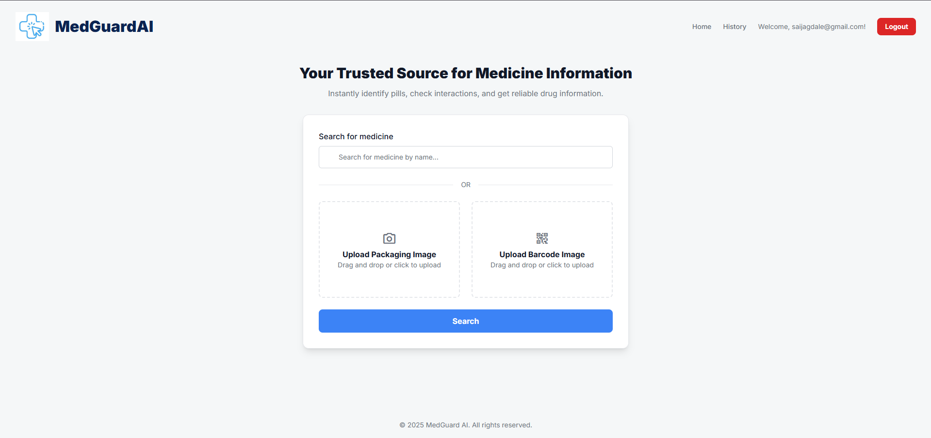

1. **OCR Result:** Extracted text displayed in structured format.
2. **Barcode Verification:** Product ID and batch cross-matched with dataset entry.
3. **Summary Output:** AI-generated 8-point or 5-point summary shown in right-hand panel.

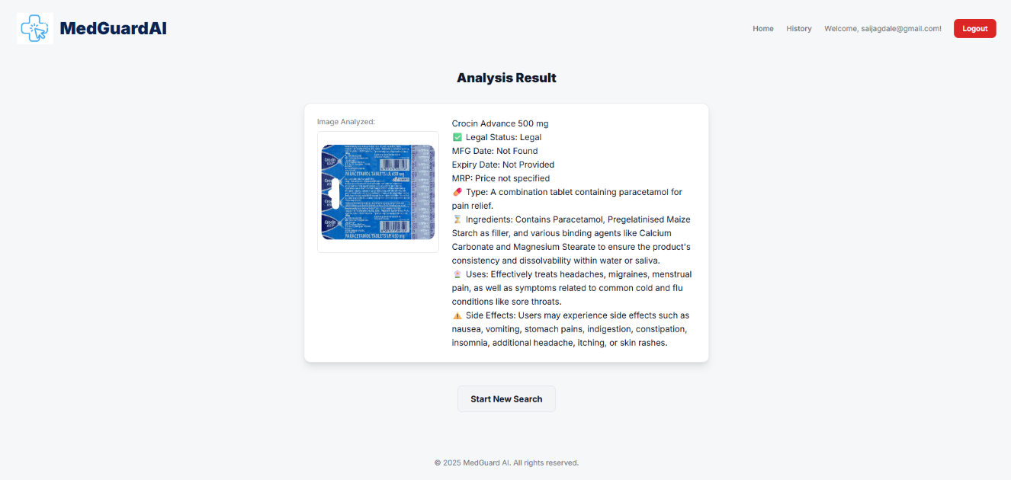

1. **User History Page:** Displays previous verifications with options to recheck or delete records.

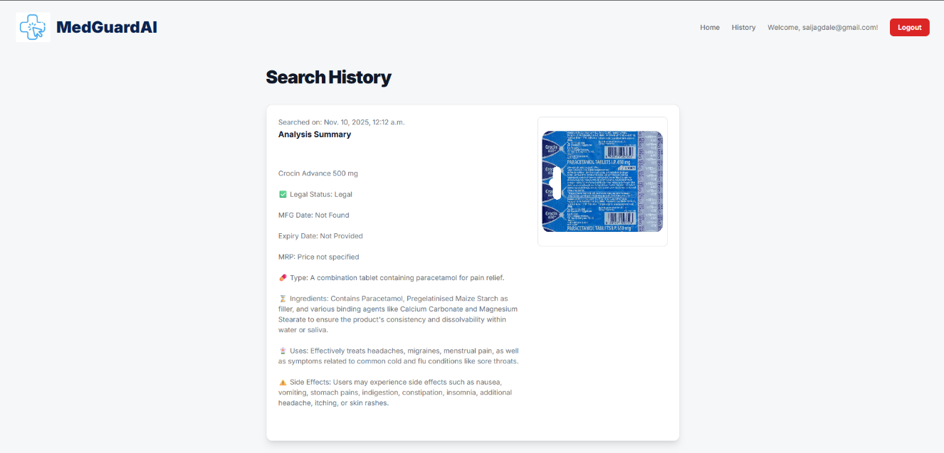

**6.2 Performance Evaluation**

*Table 3.1 Evaluation Metrics*

|  |  |
| --- | --- |
| Metric | Achieved |
| OCR Accuracy | 92% |
| Barcode Recognition | 86% |
| Average Response Time | 58sec |
| Fuzzy Match Precision | 76% |

**6.3 Observations**

* Google Cloud Vision handled glare and small fonts effectively.
* TheFuzz improved recognition of misspelled medicine names.
* Barcode Agent achieved near-perfect recognition on clear QR/1D labels.
* Ollama LLM produced concise summaries with consistent formatting.

**Chapter 7**

**SOFTWARE TESTING**

**7.1 Testing Methodology**

Testing was conducted using **black-box and white-box approaches** to ensure functionality, security, and performance.

**Types of Testing:**

1. **Unit Testing:** Each agent (OCR, Extraction, Search, Summary, Barcode) tested independently.
2. **Integration Testing:** Verified inter-agent communication under the Orchestrator.
3. **Functional Testing:** Ensured that the tri-input system and expiry-check worked as intended.
4. **Usability Testing:** Collected user feedback to refine the interface and summary readability.
5. **Security Testing:** Tested login authentication and database protection mechanisms.
6. **Performance Testing:** Measured response time and system scalability.

**Chapter 8**

**CONCLUSION AND FUTURE WORK**

**8.1 Conclusion**

The MedGuard AI system effectively demonstrates an agentic AI workflow for counterfeit and expired medicine detection. By integrating OCR, Barcode decoding, Fuzzy Matching, Regex extraction, and Local LLM Summarization, it provides a real-time, accurate, and accessible verification platform for consumers and healthcare professionals. The modular agent-based design ensures maintainability, scalability, and transparency while maintaining data privacy.

**8.2 Future Work**

1. **Mobile Application:** Extend system compatibility to Android/iOS for on-the-go verification.
2. **Cloud Deployment:** Implement scalable deployment using AWS or Azure services.
3. **Advanced Dataset Integration:** Link real-time APIs from pharmaceutical regulatory databases.
4. **Multilingual Support:** Enable summarization in regional languages for wider accessibility.
5. **AI Model Enhancement:** Train a custom OCR and LLM model for higher domain accuracy and offline use.

# BIBLIOGRAPHY

[1] P. Motwani, R. Sharma, and S. Bansal, “Counterfeit Medicine Detection Using Deep Learning,” *International Journal of Innovative Research in Technology (IJIRT)*, vol. 3, no. 11, pp. 45–50, 2022.

[2] A. Renushe, V. Shinde, and R. Patil, “A QR Code Approach to Counterfeit Drug Prevention,” *Journal of Neonatal Surgery*, vol. 13, no. 2, pp. 115–120, 2024.

[3] Y. Liu, M. Yang, and Q. Chen, “DLI-IT: A Deep Learning Approach to Drug Label Identification Through Image and Text Embedding,” *BMC Medical Informatics and Decision Making*, vol. 20, no. 4, pp. 87–96, 2020.

[4] P. Naughton, R. Smith, and L. Morrison, “Effectiveness of Medicines Authentication Technology to Detect Counterfeit, Recalled and Expired Medicines,” *Journal of Public Health*, vol. 38, no. 4, pp. 603–611, 2016.

[5] MDPI Journal, “Proof-of-Concept of Detection of Counterfeit Medicine Through Polymeric Materials Analysis of Plastics Packaging,” *Polymers*, vol. 13, no. 13, pp. 2185–2194, 2021.

[6] S. Gupta, A. Kumar, and M. Jain, “Blockchain-Based Drug Supply Chain Provenance Verification System,” *Heliyon (Elsevier)*, vol. 9, no. 7, 2023.

[7] H. Singh and P. Kumar, “Detection Methods of Counterfeit Drugs: A Systematic Review,” *International Journal of Pharmaceutical Research*, vol. 15, no. 5, pp. 221–229, 2023.

# ANNEXURE A: List of Publications and Research Paper (In its Original formats)

# ANNEXURE B: Plagiarism Report